NL Studies 2205: Exploring NL Communities Project
Group Members

- Your Assignment:
Step 1: Choose your group or complete individually
Step 2: Choose a community.
Step 3: Using the headings given below, research facts about your community. Use at least 3 websites (there may even be YouTube videos about your town).
Step 4: Find photos, images, maps, town flags, and symbols about your community.
Step 5: Gather your information and present it on a Bristol Board.
- Information that must be included on your poster:

- History – Interesting Historical Facts
- Culture – Read about the people of the area.
- Geography
  - Origin of the name
  - Population
  - Location (Include Map)
  - Waterways (rivers, ponds) or significant landforms (mountains, hills, etc)
- Economy
  - Industries (if any)
  - Main employer
- Landmarks
- Tourist Attractions
Title Heading Font : 28
Heading Information: 18 Font

Example: The Community of Fleur de Lys
History
Fleur de Lys was first inhabited by the Maritime Archaic Indians, then the Grosswater Paleo-Eskimo, 3000 years ago and then the Middle Dorset, 2000 years ago. The Dorset people, using tools such as hammerstones and chisels, quarried the soft soapstone which they shaped into pots, bowls and seal oil lamps. Also, Maritime Archaic artifacts have been uncovered at Fleur de Lys, so they may have used the quarry before the Dorset arrived. Archaeologists are still working on digs in Fleur-de-Lys.
French fishing ties

The French occupied the harbour as a summer fishing station. Between 1800 and 1850, during the winter, the French needed to protect their interests in the fishing community and they hired guardians. These guardians were given surplus food stocks in payment for looking after the French fishing gear.
2 brothers, Robert and Michael Walsh, were the community’s first settlers. The first census was taken in 1857. Fleur-de-Lys’ population was 30 people – 3 Roman Catholic families. By 1884 the population had increased to 126.
Sealing was a popular job in the late 1800s. During the late 1800’s English settlement and fishing interests at Fleur-de-Lys finally outgrew the French occupation of the settlement.

Culture
  - Artifacts various soapstone objects have been found by the Dorset. Modern artifacts include clapboard houses, boats and fishing stages.
  - Sociofacts Night out at the local pub: the Stage
  - Mentifacts The community was settled by French Roman Catholics and it is still a mostly Roman Catholic community.

Geography

Located at the very tip of the Baie Verte peninsula; on route 410.

Coordinates: 50.1188° N, 56.1292° W

The town was incorporated in 1967. The population in 2011 was 265.

The name Fleur-de-Lys was given to the area by seasonal French fishermen.
A rock formation 820 feet high which has three hummocks looks like the French Fleur-de-Lys, its national symbol and reminder of their homeland. It is also in the heart of Iceberg Alley.

Economy

The economy of Fleur-de-Lys was based on mining, fishing, and lumbering. Advocate mines opened in 1963 and Rambler mines in 1964, both in Baie Verte. This was a good source of employment until 1992 when the mines closed for good. Laid-off miners moved away. When the Cod Moratorium began in 1993 the population of Fleur-de-Lys declined. Many people are now unemployed and many have left to find work in other parts of NL or Canada
Landmark

Fleur de Lys Dorset Soapstone Quarry National Historic Site at Partridge Point. This is one of the oldest mines in NL and dates back to about 1600 years ago.
Tourist Attractions
Fleur de Lys is an outport community so it borders the North Atlantic Ocean. Because it is in Iceberg Alley, there are many icebergs to see in the spring and in the summer people can go whale and bird watching. There are also many hiking trails. The Dorset Trail and the Dorset museum near the quarry are main tourist attractions.

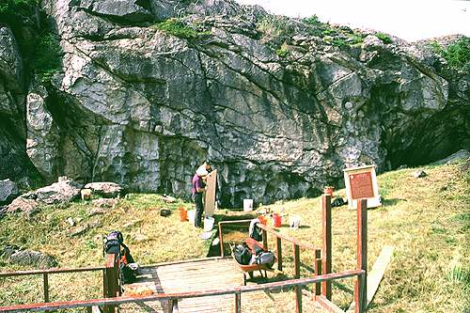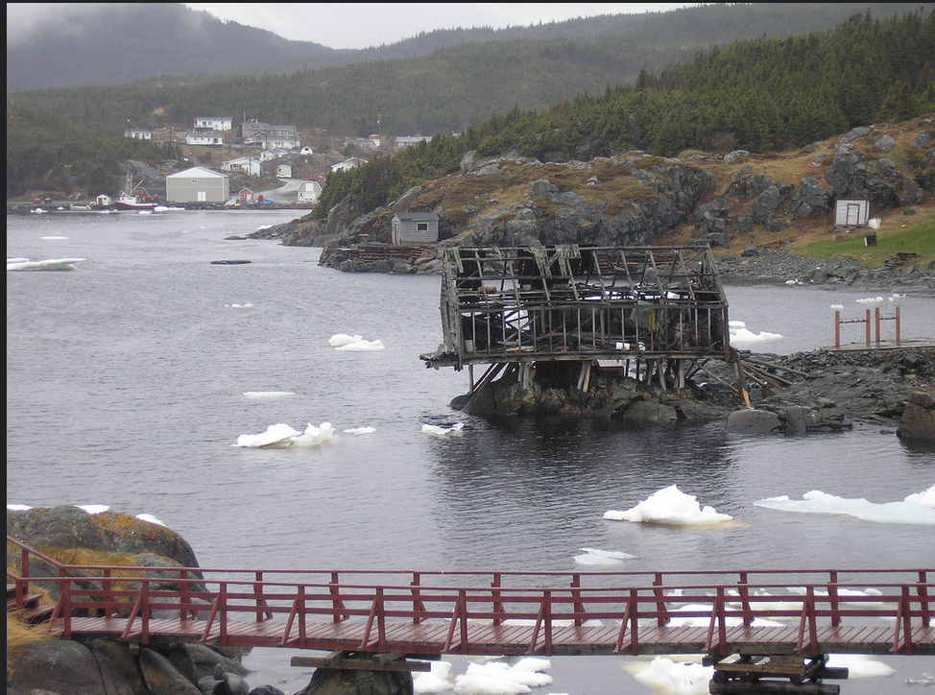
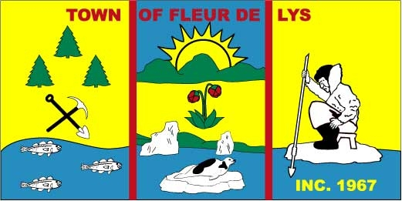
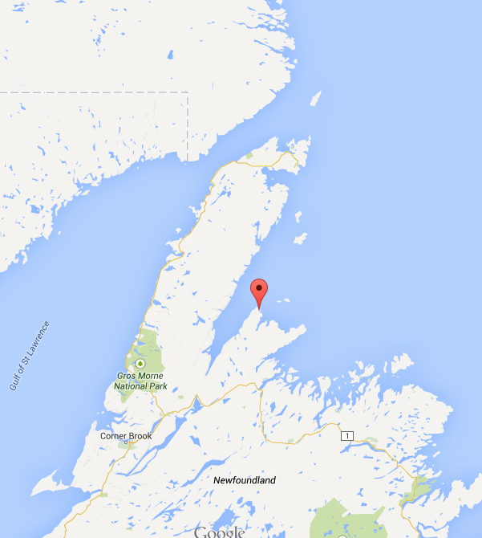

You cannot Select:
- St. John’s
- Mt. Pearl
- Paradise
- Corner Brook
- Grand Falls

Suggestions
- Port Aux Basque
- Baie Verte
- Port Aux Port
- Fleur de Lyes
- St. lawerence
- Flowers Cover
- Gros Morne
- Gander

