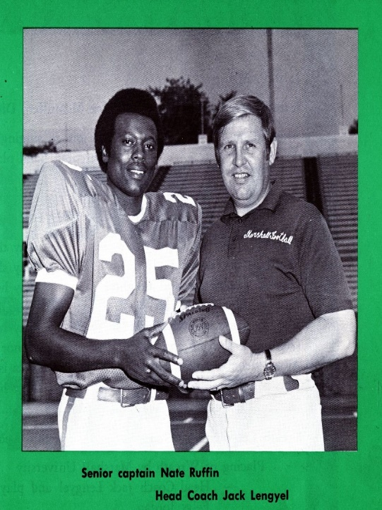

NATE RUFFIN BECAME VICTIMS VOICE

Nate Ruffin was told last-minute he would not be on the plane with the Marshall football team flying to the Nov. 14, 1970, game at East Carolina.
Ruffin was an injured defensive back, but still anticipated making the trip. At the last minute, he and a few other injured players were told that school boosters would take their seats on the jet, The Associated Press reported. On the flight back from Greenville, N.C., the jet crashed short of Tri-State Airport and all 75 people aboard died -- including most of the football team.
Left behind on campus, Ruffin passed the time by going downtown to a movie theater. That's where he heard the terrible news.
The Associated Press reported that Ruffin never knew -- and didn't care to find out -- who took his seat on the charter.
Ruffin became the team spokesman and leader after the tragedy. He helped take phone calls from parents and was asked to assist in identifying bodies. He helped bring the players together in 1971 as the team captain when the football program resumed.
At the 1997 induction ceremony of the Black Legends of Marshall -- where Ruffin represented his fallen teammates -- he said today's athletes probably don't know all they should about how the crash affected the campus and the community.
During the ceremony Ruffin talked about a Sports Illustrated article where Marshall star Randy Moss was quoted as saying the plane crash "was a tragedy, but it really wasn't nothing big."
Ruffin said he met privately with Moss after the article came out.
"The ground you're walking on was paved by many black men and many white men," Ruffin said he told Moss. "I was left behind so I could tell the story for those men who are not around now. As long as I live, I shall tell the story. As long as we tell the story, they shall live."
Ruffin died in October 2001 at age 51 from leukemia.
At the time of his death he was vice president of community relations with The Freedom Forum, an Arlington, Va.-based foundation "dedicated to free press, free speech and free spirit for all people," according to its Web site.
He also put in time as personnel manager at ACF Industries in Huntington and worked as the human resources director for The Herald-Dispatch.
Ruffin is buried at Spring Hill Cemetery next to six players who died in the crash whose bodies could not be identified and former Marshall assistant athletic director Ed Starling.
He is survived by his wife, Sharon, and three children, Carmen, Shante and Ryan.
Film Studies – Healthy Living
“We are Marshall”

- What was the name of the university team that was involved in the plane crash? How many died in the plane crash?
___________________________________________________________

- Do you think that the University president should have went ahead and cancelled the football team after the crash? Why or why not?
________________________________________________________________________________________________________________________________________________________________________________________________________________________
______________________________________________________

- Why do you think that people from the town of Huntington, West Virginia
were so sad about this tragedy even if they did not have any family members that died in the plane crash?
__________________________________________________________________________________________________________________________________________________________________

- Discuss 3 challenges that Coach Jack Lengyel faced in this movie.
______________________________________________________________________________________________________________________________________________________________________________________________________________________________________________________________________________

- Read the article about Nate Ruffin. After reading this article, write your opinions about Nate Ruffin as a person. You may also use examples from the movie to help you explain.
____________________________________________________________________________________________________________________________________________________________________________________________________________________________________________________________________________________________________________________________________________________________________________________________________________________________________________________________________________________________________________________________________________________________

- In the end, Annie Cantrell (girlfriend of football star Chris Griffen that died in the plane crash) decides to move to California. What do you think of her decision?
________________________________________________________________________________________________________________________________________________________________________________________________________________________________________________

- Overall did you like this movie? Why or why not?
________________________________________________________________________________________________________________________________________________________________________________________________________________________________________________________________________________________________

