NUTRITION LABEL WORKSHEET
NAME: _________________________

All packaged foods are required to display a standardized nutrition label. This nutrition label contains information about the caloric content, amount of fat, protein, carbohydrates, and other required nutrients.

Examine the following nutrition labels and answer the questions.
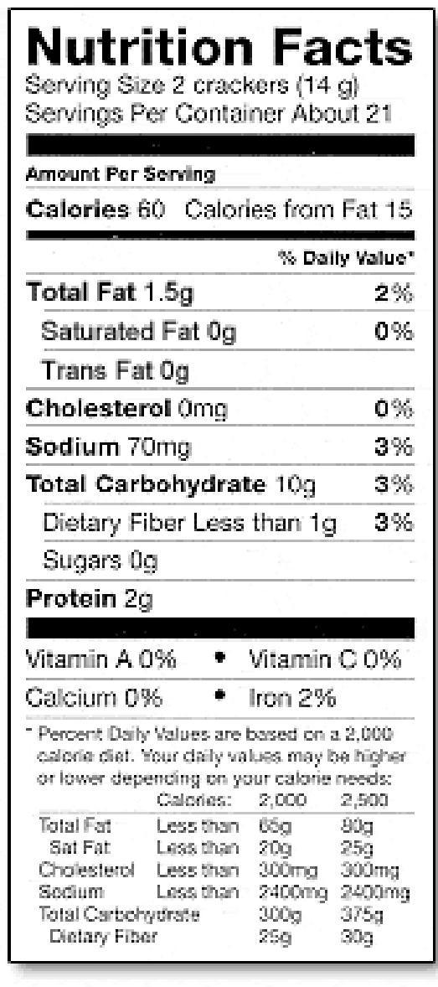
1 a) What is the serving size for the food label? _________

b) What does this mean? _____________________________________________________

2. a) How many calories are contained within one serving of this food? ___________________

b) What does this mean? ________________________________________________________

3. How many calories would you take in if you ate the whole box of crackers in one sitting? __________________________

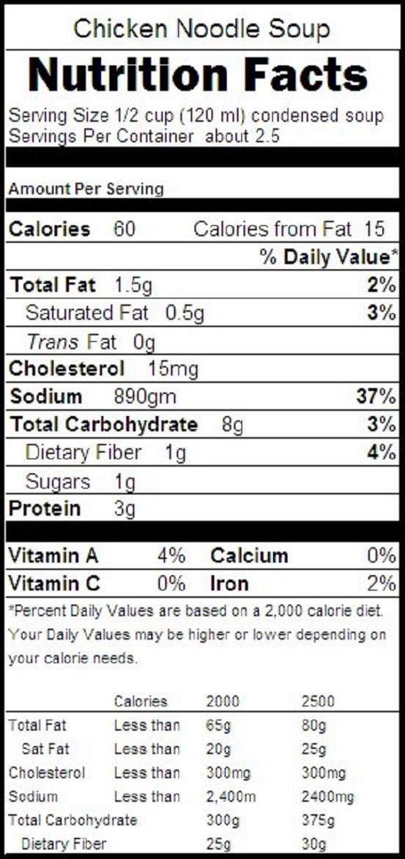

4. If you were to eat the entire can of soup, how much
sodium would you consume?
____________________________________________

5. Are the two fats in this soup know as BAD or GOOD fat? ______________

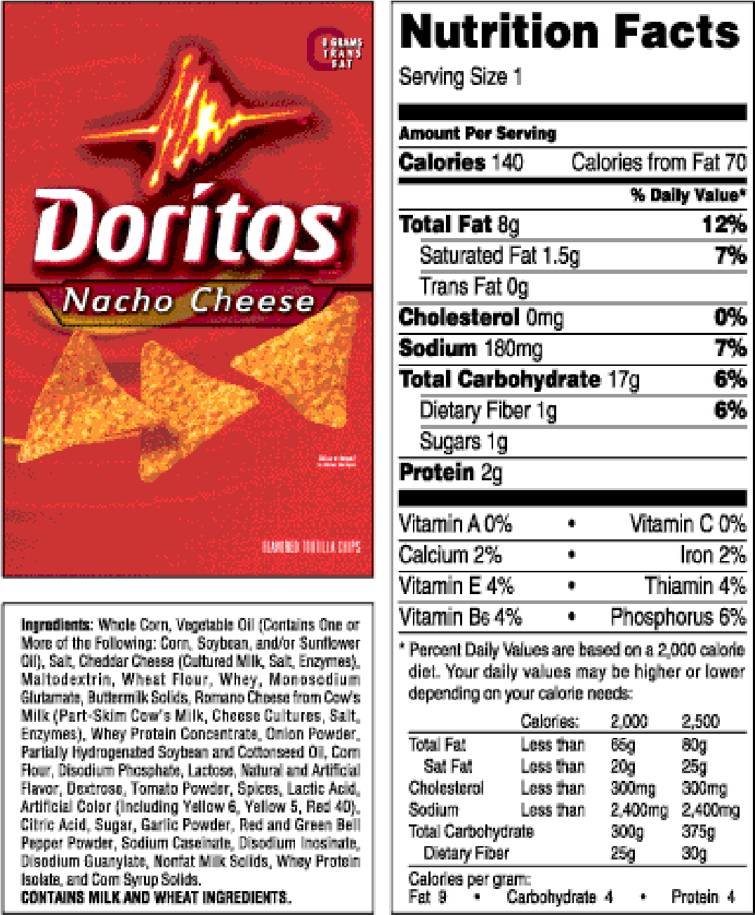
*** This serving size is 28g (1 ounce). An average bag of Doritos contains 453g (16 ounces) of chips, for a total of 16 servings per bag.***
6. How many carbohydrates would you consume if you are the whole bag of Regular Doritos?
________________

7. How much saturated fat would you get from eating the whole bag of Baked Doritos? ______________

8. How much less fat would there be in eating an entire bag of Baked vs Regular chips? _______________

9. What major nutrient increases per serving when comparing Baked vs Regular chips?
__________________

10. Which bag is better for you? Regular or Baked?
_________________

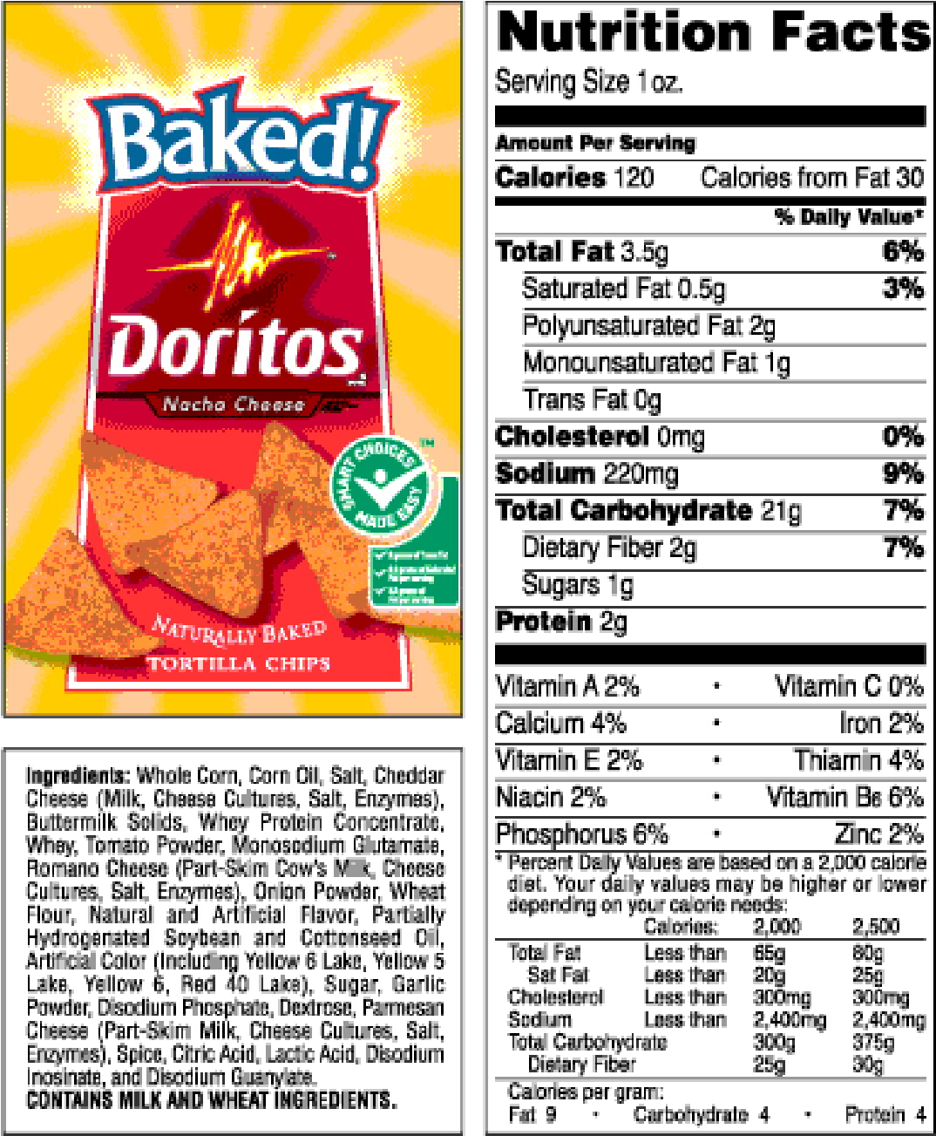

Big Mac Nutrition Facts
11. What do percent daily value mean? ____________________________________________________________________________________________________________________________

12. Calculate the percentage of your daily intake for the following nutrients: (based on a 2000 calorie/day diet)

- Calories: ____________________

- Total Fat: ___________________
Is this high, good, or low? Why? ______________________________________________________________________________________________________________________________

- Protein: ____________________

- Fibre: ____________________

- Carbohydrates: ____________

Serving Size: 7 4/5 oz (219.0 g)
Amount per Serving

Calories Calories from Fat
560 270

% Daily Value *
Total Fat 30g 46%
Saturated Fat 10g | 50%
Cholesterol 80mg | 27%
Sodium 1010mg | 42%
Total Carbohydrate 47g | 16%
Dietary Fiber 3g | 12%
Sugars 8g  Protein 25g | 50%
Vitamin A | 8%
Vitamin C | 2%
Calcium | 25%
Iron | 25%

